1. **Retrieve all players who have played more than 30 matches.**

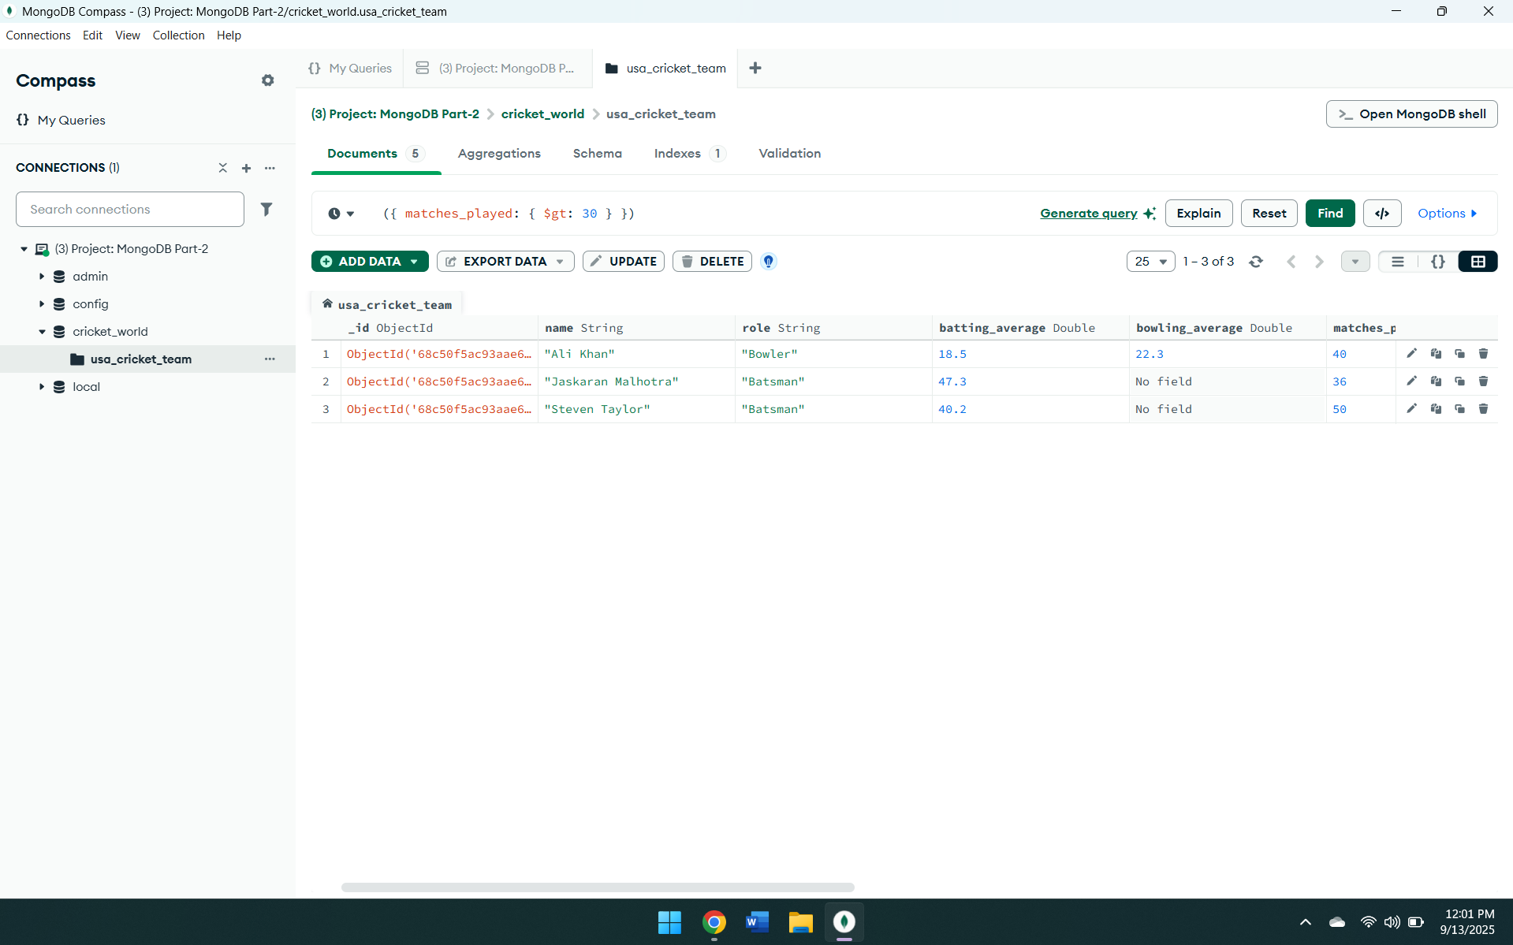

2. **Retrieve all bowlers with a bowling average less than 25.**

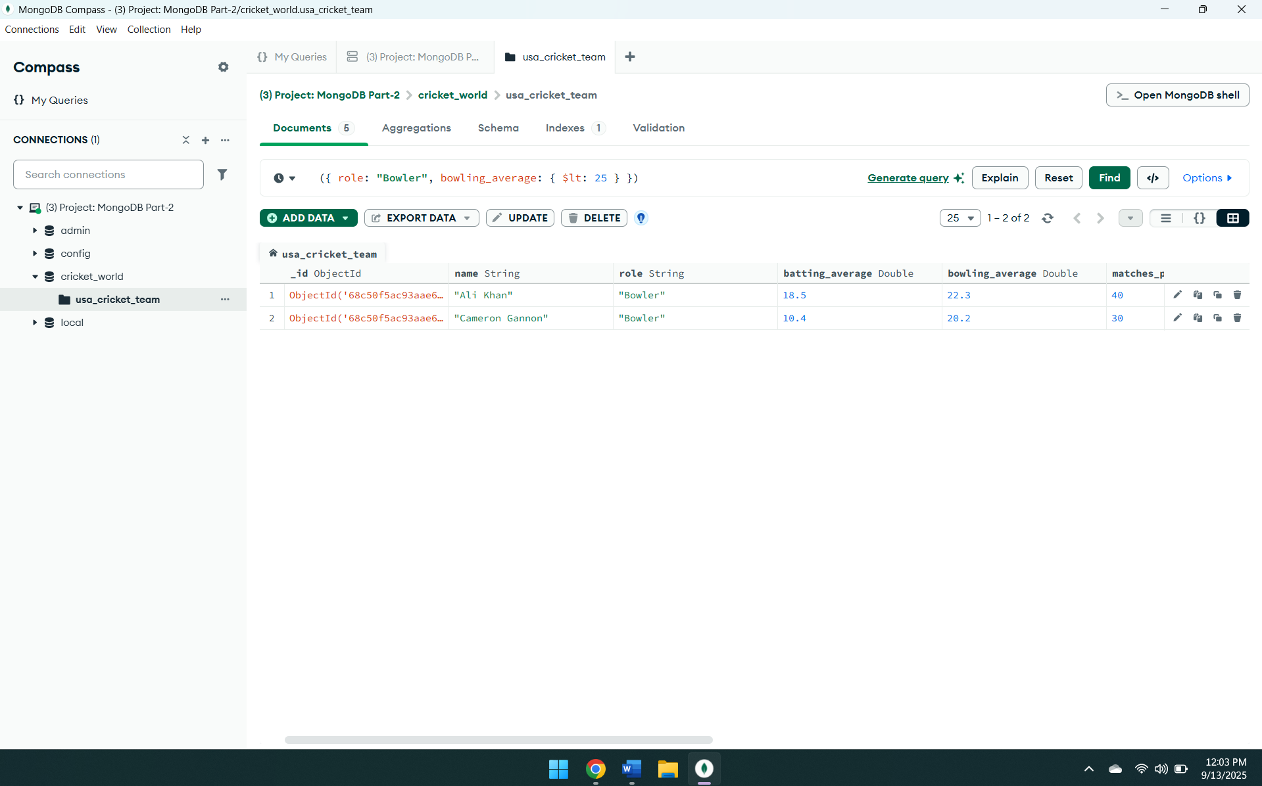

**3.Retrieve all all-rounders who have played more than 20 matches and have taken more than 30 wickets.**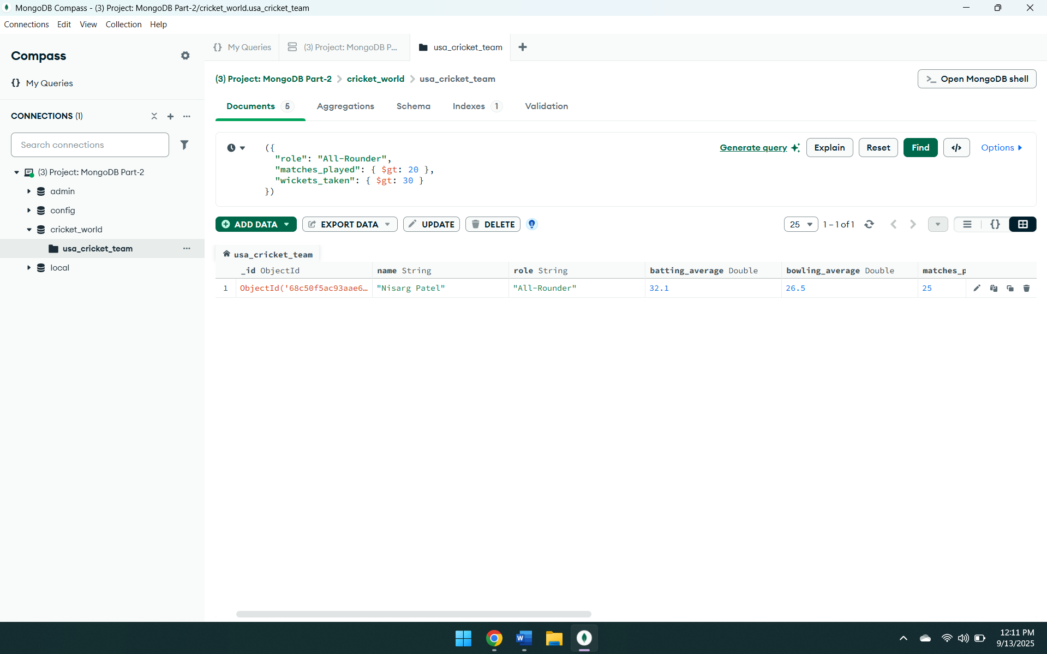

**4. Retrieve players who have a batting average greater than 40 and have scored more than 1000 runs.**

